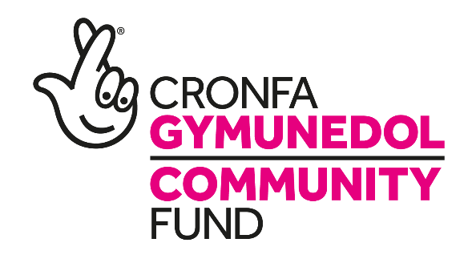

The Small Charity with a Big Dream

Business DEVELOPMENT MANAGER
SALARY: £26,716
HRS/WEEK: 37 hrs Term: 4 Years

Are you looking to work within a vibrant charity? Do you enjoy working with a range of different people and committed to helping at the heart of the community? ....then this job may be the one for you.
We are looking for an experienced Business Development Manager to lead and oversee the work of employees in our company. You will be responsible for ensuring the efficiency of business operations as well as setting strategic goals for the future. The ideal candidate will be well-versed in all matters of the charities objectives and will oversee the smooth running of multiple funded projects. They will be a competent leader able to provide guidance that enhances performance in a manner which incorporates the charity’s vision and culture.
The right person will have an appreciation of the support needs of disadvantaged and minority groups, excellent IT skills and working within a third sector organisation.
The goal will be to ensure the profitability of our company’s activities to drive sustainable development and long-term success.
The post is funded by the National Lottery Community Fund until March 2022 initially.
For an informal discussion regarding this vacancy please contact Sue Malson, Director on 01495 764078 or at one-tractwo@ymail.com.
You are welcome to submit your application in English or in Welsh. Each application will be treated equally.
Please e-mail completed applications to tractwo@ymail.com. Alternatively send application form to: The Recruitment Team, TRAC2, Folly Lane, Trevethin, Pontypool. Torfaen. NP4 8JB

Closing Date: 15/05/2020

