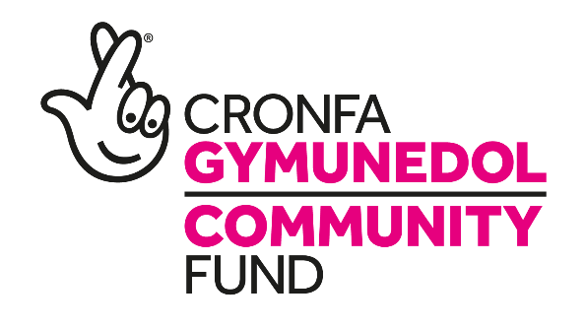

The Small Charity with a Big Dream

ShOP Manager AND VOLUNTEER CO-ORDINATOR

SALARY: £22,171
HRS/WEEK: 37 hrs TERM: 4 YEARS

Are you looking to work within a vibrant charity? Do you enjoy working with a range of different people and committed to helping at the heart of the community? ....then this job may be the one for you.
We are looking for a result driven charity shop manager to be responsible for the overall management of our popular, local shop. The successful candidate will be able to enhance customer satisfaction, meet profitability margins and manage staff effectively.
We are looking for candidates who have a background in financial planning, retail management and volunteer recruitment.
The manager will be responsible for the planning, and direction of day-to-day operations including all administration and ensuring the protection of employees, volunteers, and customers by providing a safe and clean environment.
The post is funded by the National Lottery Community Fund until March 2022 initially.
For an informal discussion regarding this vacancy please contact Hannah Davies, current Administration Lead on 01495 764078 or at tractwo@ymail.com
You are welcome to submit your application in English or in Welsh. Each application will be treated equally.
Please e-mail completed applications to tractwo@ymail.com. Alternatively send application form to: The Recruitment Team, TRAC2, Folly Lane, Trevethin Pontypool, Torfaen NP4 6JB.

Closing Date: 15/05/2020

