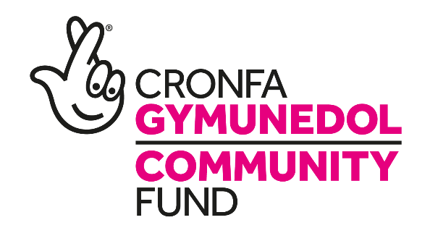

The Small Charity with a Big Dream

WAREHOUSE Manager
SALARY: £22,171
HRS/WEEK: 37 hrs TERM: 4 YEARS

Are you looking to work within a vibrant charity? Do you enjoy working with a range of different people and committed to helping at the heart of the community? ....then this job may be the one for you.
We are looking for an organised Warehouse Manager to supervise the receipt, dispatch, and storage of merchandise in our warehouse. The Warehouse Manager will oversee picking, storage, receiving, dispatching, security, maintenance, sanitation, and administrative functions. You will oversee, train, evaluate volunteers. You will ensure the maintenance of company assets.
You will begin by overseeing the new sales project of furniture starter packs, identifying key demographics and create sales marketing strategies. You will have excellent customer service and sales skills and will be responsible to senior management.
To ensure success you need to multitask effectively in a fast-paced, dynamic environment, and perform your duties in a manner that maximises profits. Applicants should be dedicated, competent and have strong leadership skills. Reporting to senior management sales and operational figures.
The post is funded by the National Lottery Community Fund until March 2022 initially.
For an informal discussion regarding this vacancy please contact Hannah Davies, current Administration Lead on 01495 764078 or at tractwo@ymail.com
You are welcome to submit your application in English or in Welsh. Each application will be treated equally.
Please e-mail completed applications to tractwo@ymail.com. Alternatively send application form to: The Recruitment Team, TRAC2, Folly Lane, Trevethin Pontypool, Torfaen NP4 6JB.

Closing Date: 15/05/2020

