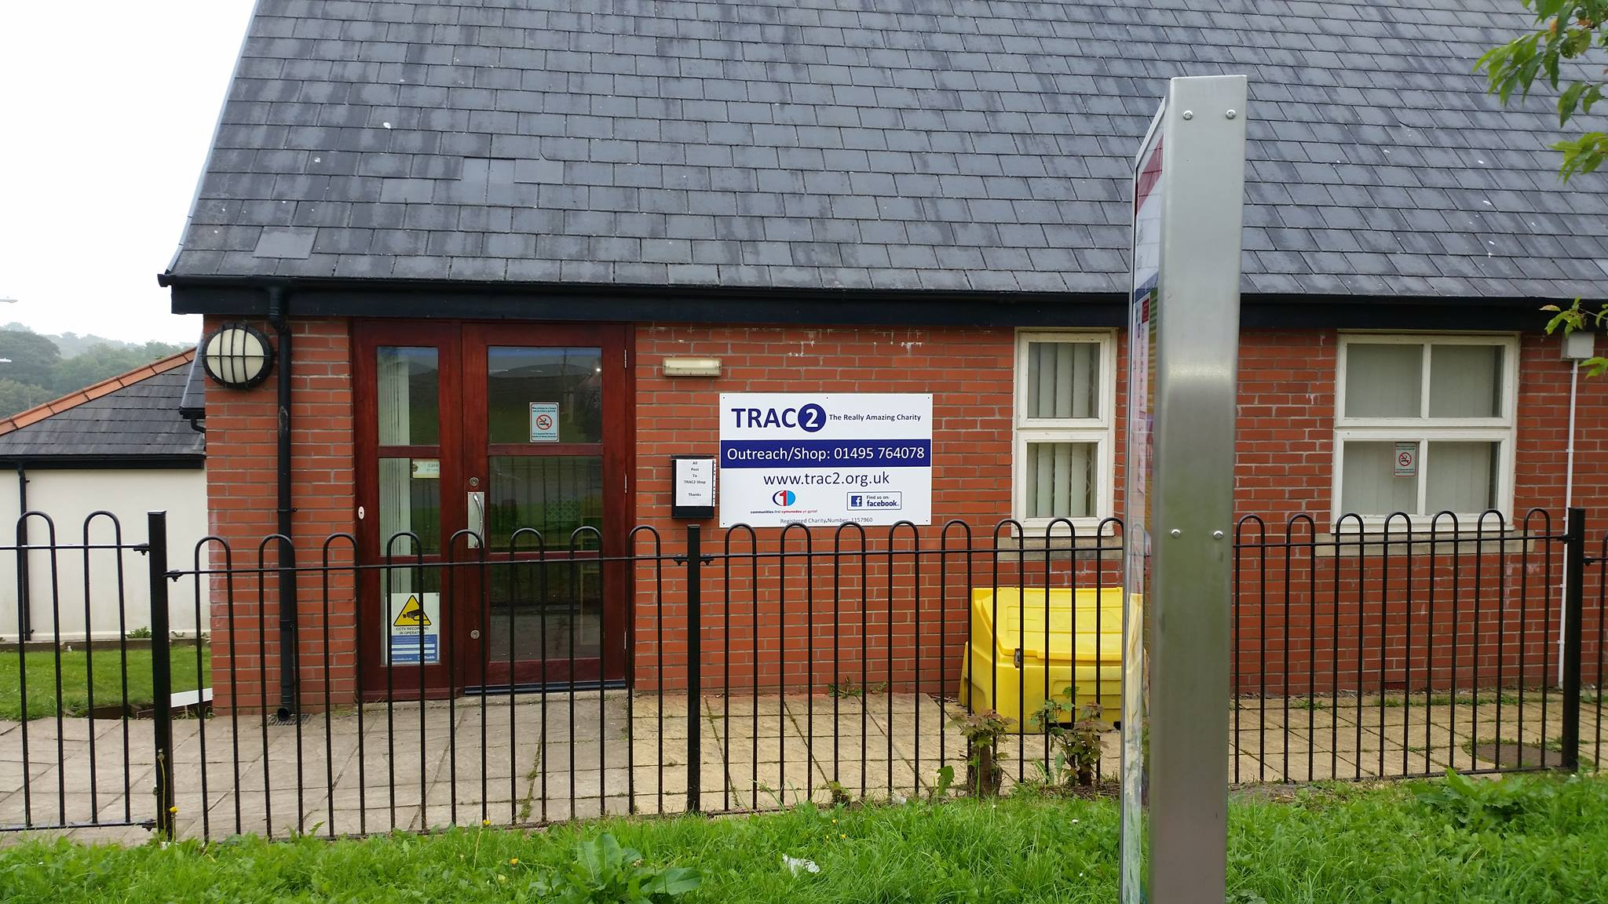

TRAC2

ANNUAL REPORT

The Really Amazing Charity Name
Email: hannah@trac2.org.uk  Website: trac2.org.uk | Tel: 01495764078  Folly Lane Trevethin Pontypool NP4 8JB

Message from Nathan Yeowell
Dear Friends,
I first got involved with TRAC2 in the summer of 2015, helping with local efforts to provide clothes and bedding for Libyan refugees stranded in the camps in Calais. I became a trustee the following year and now, just over four years later, I’m honoured to be taking over as Chair.

And what a year it’s shaping up to be. We’re in the process of bidding for new funding that will allow us to overhaul our existing operations and proceed with ambitious new projects, shaped around the need that we know exists across Torfaen.

At the heart of these activities is our fantastic, and growing, family of staff, volunteers and supporters. They put in the hard work and long hours that help their neighbours overcome social and economic hardship. They bring their local communities together. They are a lifeline for many families in Pontypool. They are an inspiration to me, but not just me. Speaking at last year’s Evening of Thanks, A-list supporter, Hollywood star and Port Talbot boy Michael Sheen told us that:

‘The crisis intervention delivered by the team, supported by volunteers and the community, is saving lives. It is treating people with the dignity and the love they deserve. And it is a love… it is a tough love, a get-your-hands-dirty love, it can sometimes be a furious love, and it’s what gets things done when they need to be done. Whether it is as simple as ensuring that someone has a kettle and some electricity just to make a cup of tea. Or someone who will talk to someone, show some solidarity, share their experiences, draw on what they’ve gone through to connect with someone who is going through it in that moment and feels like they might be alone. Finding someone a home after years of living on the streets. The interventions that TRAC2 deliver really, really matter.’

Michael was right. What we are doing matters: we’re changing people’s lives. These changes may be small, and they might seem simple, but as acts of love they are contagious, and they ripple outwards. We will all need the unconditional support of others at some point in our lives, and it is a privilege to play my part in supporting TRAC2 and the group of extraordinary individuals who make its work possible, and are always there – without recognition or fanfare – when people need our support the most.

Thank you!
Nathan Yeowell

Summary of 2018-2019
The Really Amazing Charity (TRAC2) is dedicated to the eradication of poverty and works tirelessly to help people who are often at their lowest ebb with the tailored support they need to start rebuilding their lives.

The Really Amazing Charity (TRAC2) was established in 2012 in answer to the growing financial hardships faced by so many in the community. We are dedicated in the fight against poverty and high street debt that can lead to relationship breakdowns, the separation of families and homelessness. It is not an easy fight nor is there an end in sight but what we do does make a difference and we will continue to support those who come through our doors for as long as we are needed.

This year has seen its share of hardships, but it has also seen a lot of joy. Our volunteer Ben turned 30 and we surprise him with a Harry Potter themed birthday party and Hannah, our Administration officer, discovered she was to be a grandmother for the very first time. A particularly proud moment was Sue receiving an award on International Women’s Day for her contributions to the Ghurkha Community. Sue has also been successfully nominated for a Community Hero award; we should have the results of this award next year.

We have been so proud of some of our volunteers who have gone on to find full time employment and we have welcomed a few new members to the TRAC2 family. We have hosted dinners and fundraisers, received support from so many amazing businesses, organisations and communities and have been at the forefront of some new initiatives. We hope the next 12 months will bring some exciting new challenges, support and above all, a new hope for those who need us.

Who we are!
We are dedicated in the fight against poverty and high street debt that can lead to relationship breakdowns, the separation of families and homelessness. We want to help change the circumstances that lead to a family not being able to fulfil even the basic necessities for their families. “Poverty means not being able to heat your home, pay your rent, or buy the essentials for your children. It means waking up every day facing insecurity, uncertainty, and impossible decisions about money. It means facing marginalisation – and even discrimination – because of your financial circumstances”. (Joseph Rountree Foundation, 2018). It is not an easy fight nor is there an end in sight but what we do does make a difference and we will continue to support those who come through our doors for as long as we are needed.

TRAC2 have developed three programmes that has evolved and been shaped by the community it supports. These programmes offer complete wrap-around support for our clients and will help guide them to make positive changes in not just their lives, but the lives of their families and community. Below is a brief snapshot of our support timeline from the moment a participant walks in through our doors until they are ready to move on to the next phase. This could be through independence and no need for further support or ic could be a refer to various agencies, including employability. Examples of our support are highlighted later in the report in our Impact Stories.
Our programme ribbon shows a snapshot of the support timeline for our participants

Our programmes successes are due to our strong network of support. Agencies from across the sector believe in the work that we do and together we are able to support hundreds of people a year. Below we have provided a brief look at our services.

Programmes
Community Outreach
We are a social hub at the heart of the community and provide a safe space for people to access when they are at crisis point. TRAC2 hosts a wide range of 3rd sector agencies, and at any given day of the weekday, members of the public can access our safe space, in the knowledge that they can get the help they need in an environment they feel comfortable in.

Crisis
Our Crisis Support programme provides tailored support to individuals and families often in acute crisis. Households who have been rehoused because of an emergency, family breakdown, eviction, domestic violence, previous homelessness, or any other adverse life events, often find themselves without household essentials. Whether it be a bed, sofa, chest of drawers, clothes, kitchen appliances, or the whole package; we will source it so that the household can focus on what’s most important; getting back on their feet.

Meals
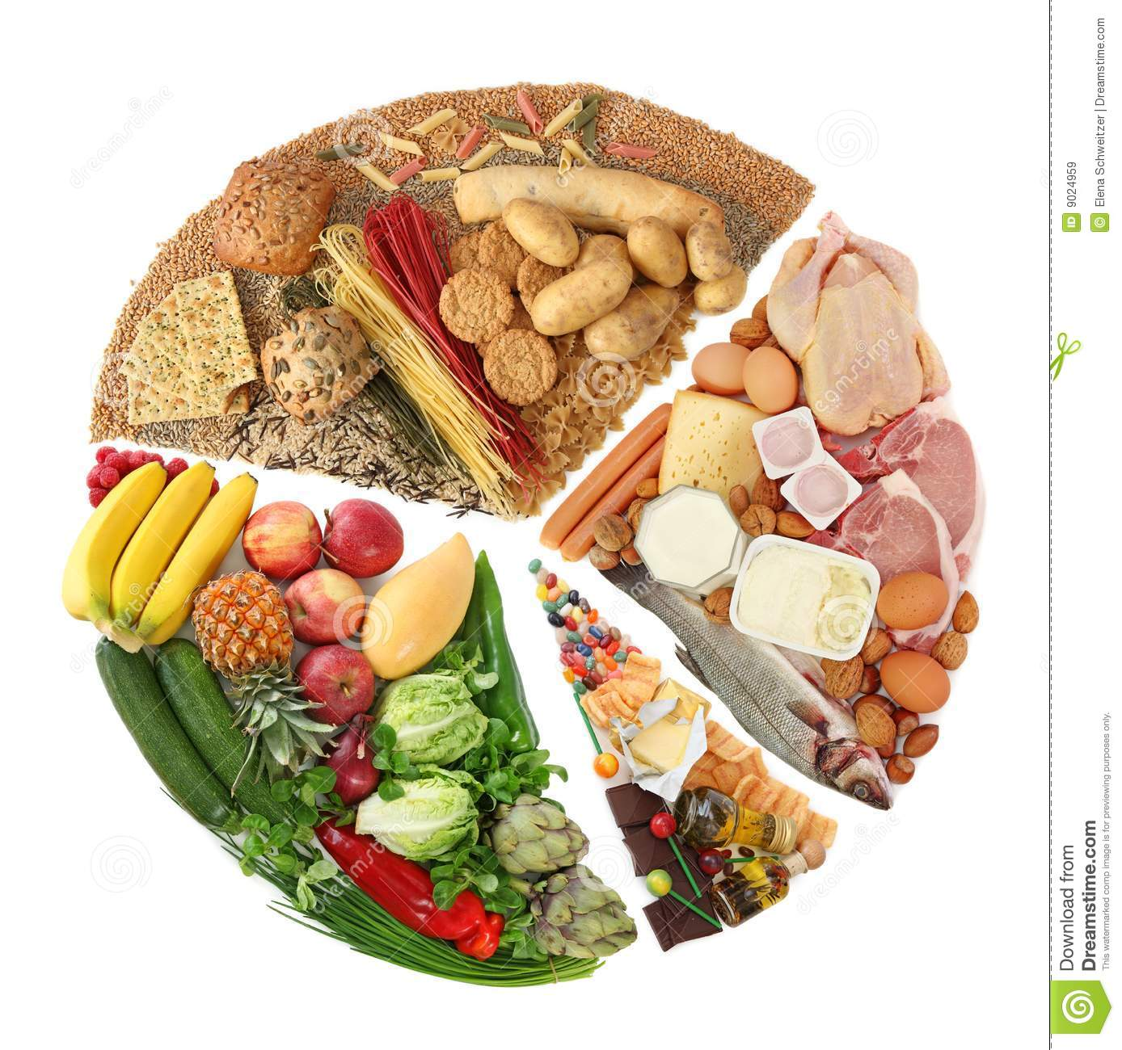
Food poverty is a sad reality many people in our community are faced with; it’s a reality we’re not content to stand by and do nothing about. For many years now, we’ve issued food bank vouchers, but with food banks facing unprecedented levels of demand, earlier this year we decided to start our own weekly Fareshare project; offering nutritional, fresh foods at a very low cost to enable people to feed themselves and their families. This program has rapidly become so popular, that we’re considering opening a second venue to serve more people.

What we do!
Our shop continues to provide low cost items to the local community and remains a popular stop for shoppers. Thanks to our staff and volunteers, our shop has seen its biggest turnover to date and continues to draw customers from across the Borough, who come for a low-cost bargain. By offering quality items at affordable prices, it is our aim to divert clients from expensive shops, high-interest loans, and to encourage reuse of items, rather than them going to landfill!

This year, an incredible 12,821 people visited our shop. They have visited for the following reasons:
- Shopping
- Donating
- Enquiries
- Support Request

SHOP STATS

Community Feedback
We recently conducted a survey, face to face and online, asking the community what they thought of our shop. We received over 100 replies revealing overwhelming support for our shop and we loved reading your responses and suggestions. We wanted to know what changes they would like to see and how we could improve. We were impressed by all the suggestions, so much so, that many of them have now been implemented. We especially love our new décor, and, with just a few changes, the shop feels more spacious and appealing. We would like to say a big thank you to everyone who took part. Your opinions are invaluable.

Community Outreach
We have had an incredibly busy year at TRAC2. The support we have delivered has increased along with the number of items donated that are lovingly accepted to help make a house a home. We opened our doors to 4952 people this year so far and we expect December to be our highest month due to the increase in support requested.

This year, an incredible 4,952 people visited our office. They have visited for the following reasons:
- Shop
- Sign Posting
- Enquiring
- Client
- Agency
- Food Vouchers

OFFICE STATS

Outreach Agencies
Multi-agency working has been an increasingly popular initiative for many years. TRAC2 has been a huge supporter of this way of working and the positive changes this makes to the community as a result. resources, information, knowledge and skills help us help our service users better. To date we have upwards of 22 different specialist support workers utilising our offices.
Direct Gov looked at a Multi-Agency Sharing Hub and completed a report that listed the 6 key benefits of which are:
1. Acting as a single point of entry – gather all notifications related to safeguarding in one place.
2. Enabling thorough research of each case to identify potential risk (and therefore the
opportunity to address that risk)
3. Sharing information between agencies, supported by a joint information sharing protocol
4. Triaging referrals, exemplified in the use of agreed risk ratings.
5. Facilitating early intervention to prevent the need for more intensive interventions at a later stage.
6. Managing cases through co-ordinated interventions.

This has worked extremely well in this community as not only does this help the clients but all of this information, support and knowledge is available in one place, it does not cost them any money to travel to the location and they see the same faces and therefore are able to build the trust that a larger, single service supplier is not always able to achieve.
Our Impact
TRAC2 aims to make a tangible difference to peoples’ lives. By addressing clients’ acute needs and referring them on to trusted partners for tailored support, we hope to assist people as they get back on their feet.
In the last 12 months we have supported an incredible 264 households, a 9.7% increase on last year’s figures
In the last 12 months we have donated an incredible 5175 items, a 15.5% increase on last year’s figures

The infographic is a snapshot of not only some our outcomes from the last year but also some of the harrowing facts and figures facing the people of Torfaen. A 40% rise in child poverty is a heart-breaking figure that is only predicted to rise over the next few years with many predicting a scary statistic that 1 in 3 children will be living in poverty by 2023. The news that 600,000 children in Wales are considered as ‘living in poverty’ but that 90,000 of these children are considered as living in ‘extreme poverty’ with the difference being that the lower number have household incomes falling below the average household income.

The rise of one of more deprived wards in Torfaen from 14th to 40th in the Multiple Deprivation Index should have been a positive outcome but when coupled with a dramatic drop to 10th in mental health and life expectancy, not such great news.

TRAC2 has worked tirelessly against these scary statistics. In our donations of beds and settees alone, we have saved our recipients over £300,000 in potential debt. We provided over 2000 meals and 13,957 items of support was given by us in the last 12 months. And in the last 10 months alone, over 4000 people utilised our drop-in services with over 12,000 accessing our shop.

Our Impact Continued…
Our clients are at the forefront of all that we do here at TRAC2. We receive referrals from a range of partners, including the household themselves, often requiring immediate support. Individuals who have recently been rehoused for whatever reason, will often be in need of some or all household essentials. Through donations very generously given by members of the community (and sometimes beyond!), we’re able to provide quality household essentials, clothing, food, and much more, to those households at the point of need. We believe the key to recovery is enabling individuals and families to focus on what is important; this means alleviating their worries however we can. Upon referral, TRAC2 will assess the household’s needs, assist with as many needs as we can, and will then refer onto one of our many partners to support with more specialised needs. Take a look at the impact TRAC2 has had on these lives.

Meet Steven*
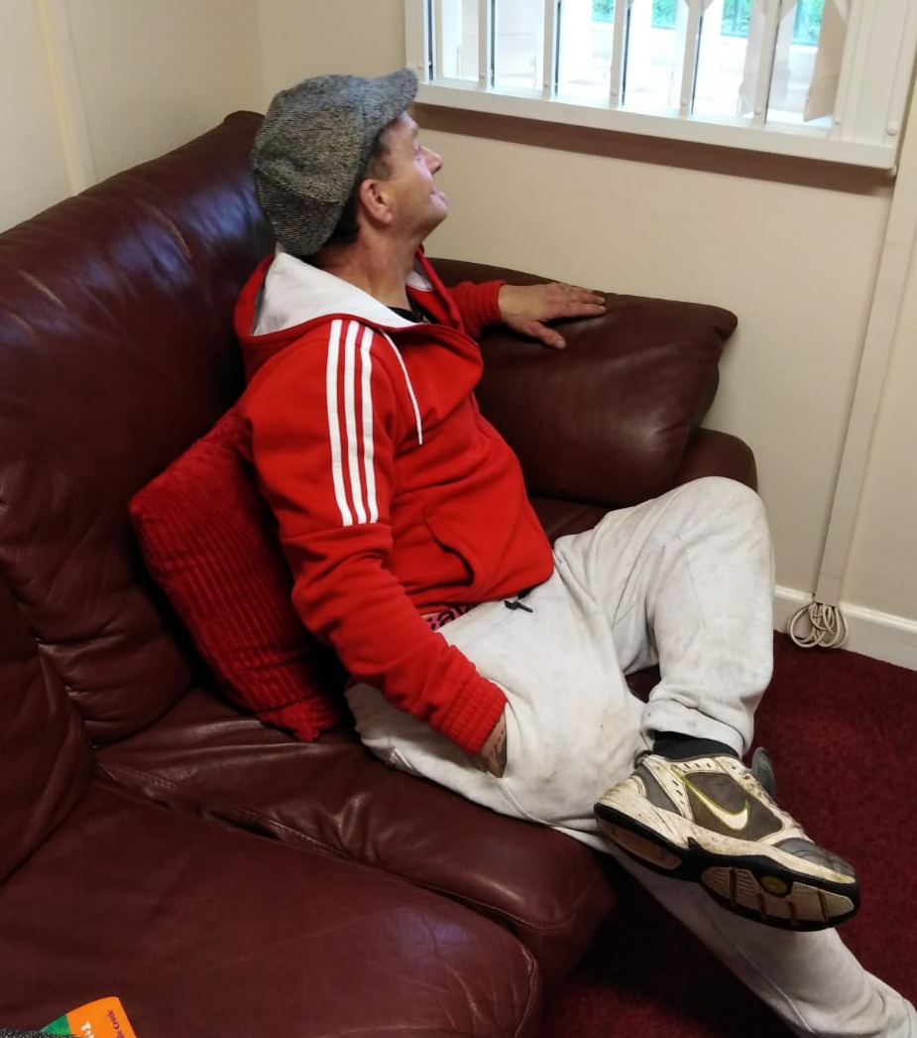
Previous History: Steven has been supported by TRAC2 for over three years. He has had long periods of street homelessness and sofa-surfing. We supported throughout the winter with clothing, bedding, sleeping bags food and hygiene supplies. We provided a Christmas lunch and a hamper of appropriate items. He had moved to several locations during this time due to vandalism, mainly having his tent and meagre belongings set on fire.

Steven’s last location, and the reason support needed to become more intense, was in a garage, however, residents became aware of this and he endured weeks of discrimination and intimidation, he resorted to sleeping in a shed. We contacted one of partner agencies and, through us, he began to finally engage.

Private accommodation became available, but Steven was concerned that he would need to get an advance payment (to pay for the bond and rent advance) on his Universal Credit lowering his monthly payment. But this was negotiated on his behalf, and Steven was able to move in.

He voiced concerns regarding household items as he had no discretionary income remaining. We reassured him that we would help, and we provided this gentleman with everything he needed to live comfortably. Steven has continued to engage, has managed his tenancy successfully and is now living independently. We continue to check in on him and he can call us if he has any issues.

Steven, a few months later, agreed to take part in some feedback for us. These were his responses. (permission granted to use feedback in this case study)

Q: Using only 3 words, please describe how you felt before engaging with TRAC2

A: Lonely, scared, hungry and angry

Q: How were you supported by TRAC2?

A: You got those ladies to help me find somewhere to live. Then you got me furniture, so I didn’t have to sleep on the floor and stuff.

Q: Using only 3 words, describe how you feel now after having support from TRAC2

A: Happy, settled, warm and safe and full

Q: Where do you think you would have been without this support?

A: Cemetery, no lie. I would have been dead I know it. I just can’t believe you did me a home in less than a day.

These honest and harrowing comments highlight the terrifying truth many homeless people feel.

Our personal project, affectionately known as ‘A House to a Home’, has been by far our most amazing achievement. We have successfully supported and furnished 265 houses that are now homes to varying degrees for so many who had nothing.
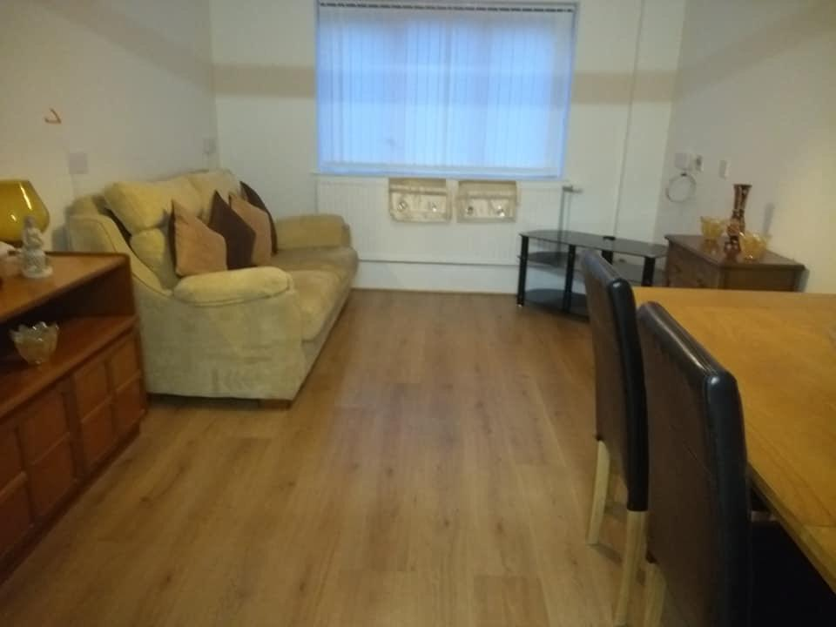
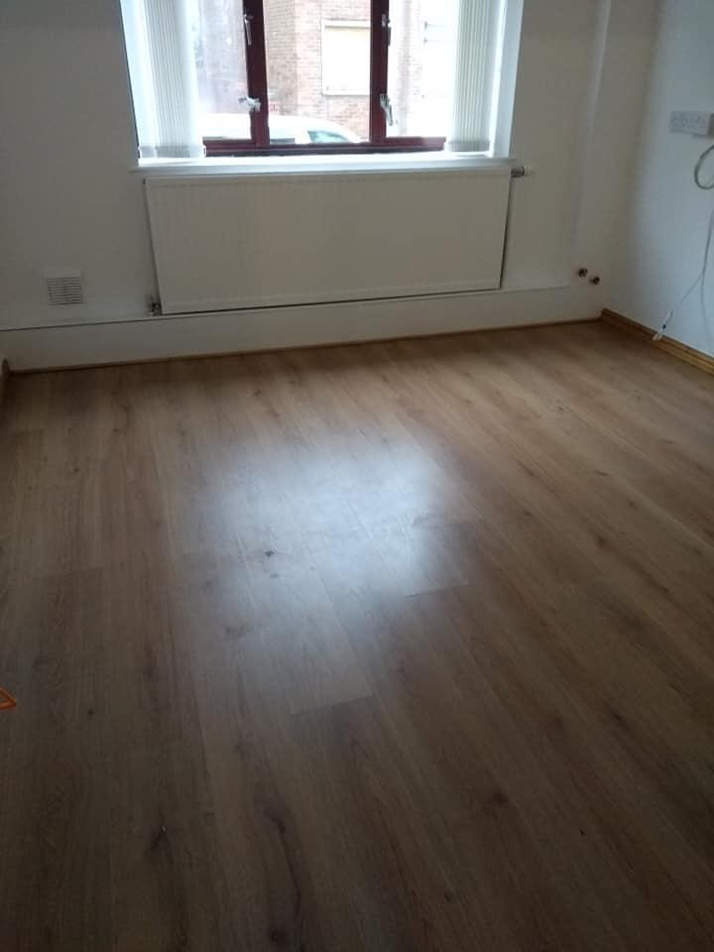

These are the before and after pictures of a home we created for a gentleman who had been homeless for a long time before he attended our annual Christmas Meal and agreed to be supported by our partner agencies.
COVID-19 SUPPORT

TRAC2 Support Snapshot
In February we supported 1596 families who were experiencing symptoms and were among the first households to be shielded.
• 18 household’s food, gas and electric and not for household items.
• We also supported 13 households make Universal credit applications and completed 6 PIP applications.
• We also supported with Discretionary Housing Payment applications and DAF Payments.
• We answered 149 calls for support
• We delivered 22 Fare share per week a total of 88 in February.
• Plus, 16 referrals to the foodbank which provided 123 meals
• We also had 894 people access our shop for low cost household items
• 12 outgoing well-being phone calls
• 272 household items donated

In March we supported 1458 individuals with emergency provisions
• 37 direct referrals due to Covid-19.
• We completed 21 Universal Credit applications,
• received over 300 phone calls for support
• applied for 9 DAF applications.
• 15 referrals to the food bank providing 150 meals
• Our FareShare deliveries increased to 25 per week so 125 packages were delivered.
• We also had 428 people access our shop before we were forced close.
• 22 outgoing well-being phone calls
• 451 household items donated
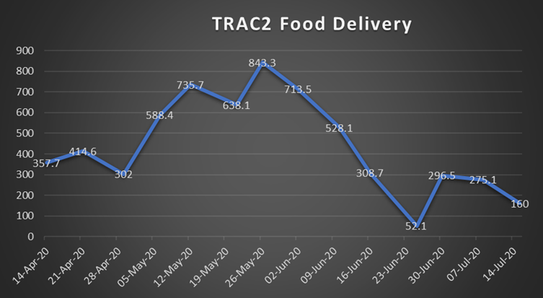
In April we supported 2998 individuals
• 203 supported with emergency provisions, directly from TRAC2
• 398 calls for support
• 18 referrals for financial inclusion advice (TCBC)
• 65 foodbank referrals providing a total of 549 meals
• Fareshare increased again to 32 deliveries totalling 128 parcels
• 49 outgoing well-being phone calls
• 1653 household items donated

In May we supported1441
• Supported 2 households with emergency gas and electric
• Fareshare we supported 93 households which equates to 279 meals
• Emergency food parcels totalling 1720 items for 80 households totalling 573 meals
• 61 wellbeing phone calls were made
• 359 incoming calls for support
• 14 applications for UC, DHP or DAF were made
• 43 incoming referrals or contacted for advice for clients
• 110 Household items donated

So far in June we have supported 987
• Fareshare we supported 60 households of individual and families totalling 180 meals
• Emergency food parcels, with a total of 104 households totalling 265 meals
• 186 incoming calls and messages for support
• 12 applications for benefits and grants including EMA for new students
• 52 wellbeing phone calls
• 42 incoming support or advice for clients
• 250 household items donated

This snapshot shows that from February to June we have provided support 8208 times to families and households throughout Torfaen.

Not only have we provided 3060 meals through the local foodbank, we have delivered, an incredible 5,463 3 x meals over 3 days to adults and 2,223 meals to children.
Stan and Sue have collected and delivered an impressive 6.2 tons of food donated by Morrisons and was distributed to Trussel Trust Foodbank and various other food distributers throughout Torfaen.
70% BRON AFON
18% PRIVATE
7% TEMP/EMERGENCY ACCOMMODATION
3% MELIN
1% HOMELESS
1% COMPLEX/ADAPTED

TRAC2’s Fareshare project has been invaluable through recent months. This project saw us provide meals for over 500 households. 607 adults and 247 children have received meals during Covid through TRAC2.

A message from Sue

“I would have been dead I know it. I just can’t believe you did me a home in less than a day.”
My last year’s message:
- Poverty is at an all-time high
- Mental health is no longer a taboo subject
- Domestic violence, physical or mental will not be tolerated by any gender
- Everyone will eat at least one meal a day
- Everyone deserves to be in comfort with warmth and light
- Adults and children will have clean clothing and shoes
- Everyone’s voice will be heard
- Again, another year in the life of TRAC2 is hectic
- Again, an even greater demand on our services
- Again, the only charity that deliver what we do!
- Again, in 2018, we should not be here!!!

I have used last year’s message because I wanted to see what has changed. But the only change is the year and that more people than ever have walked through our doors for support.
This year, lives were saved! Yes, Saved!
My role has evolved to help those who cannot help themselves. Those, so distrusting of authoritative figures that they will not answer the door or their phones, letters piled up, unopened. Those, who feel so alone that they don’t think they deserve help and no longer feel wanted or valued. Engagement must come from the heart. Believing that a life, and living, is one of the most valued experiences one can have. Connection = Engagement. Never be forceful, listen to that person and truly understand and feel for that person’s situation and treat them with dignity and respect.
Once a connection has been made, miracles of belief in oneself can happen’.

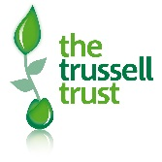
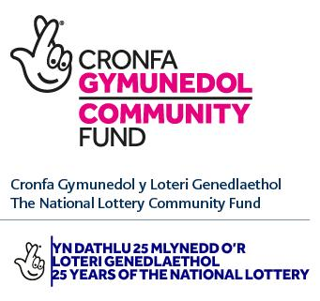
THANK YOU!

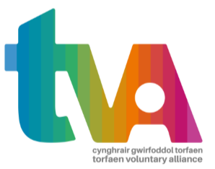

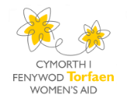
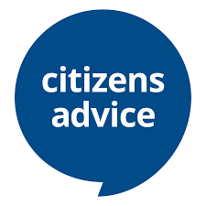
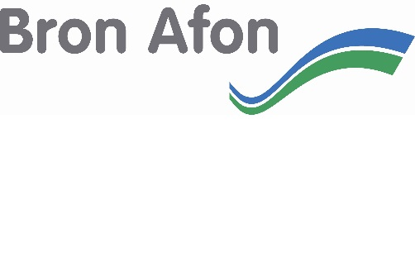
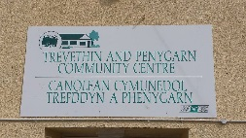
TRAC2 Charity would like to extend our huge thanks to all our working partnerships.

